AI Assisted Coding
Assignment 6.1
B.Tejaswi
2303A52123
Batch-40

Experiment 6: AI-Based Code Completion: Working with
suggestions for classes, loops, conditionals

Task Description #1 (AI-Based Code Completion for Loops)
Task: Use an AI code completion tool to generate a loop-based
program.
Prompt:
“Generate Python code to print all even numbers between 1 and N
using a loop.”
Expected Output:
• AI-generated loop logic.
• Identification of loop type used (for or while).
• Validation with sample inputs.
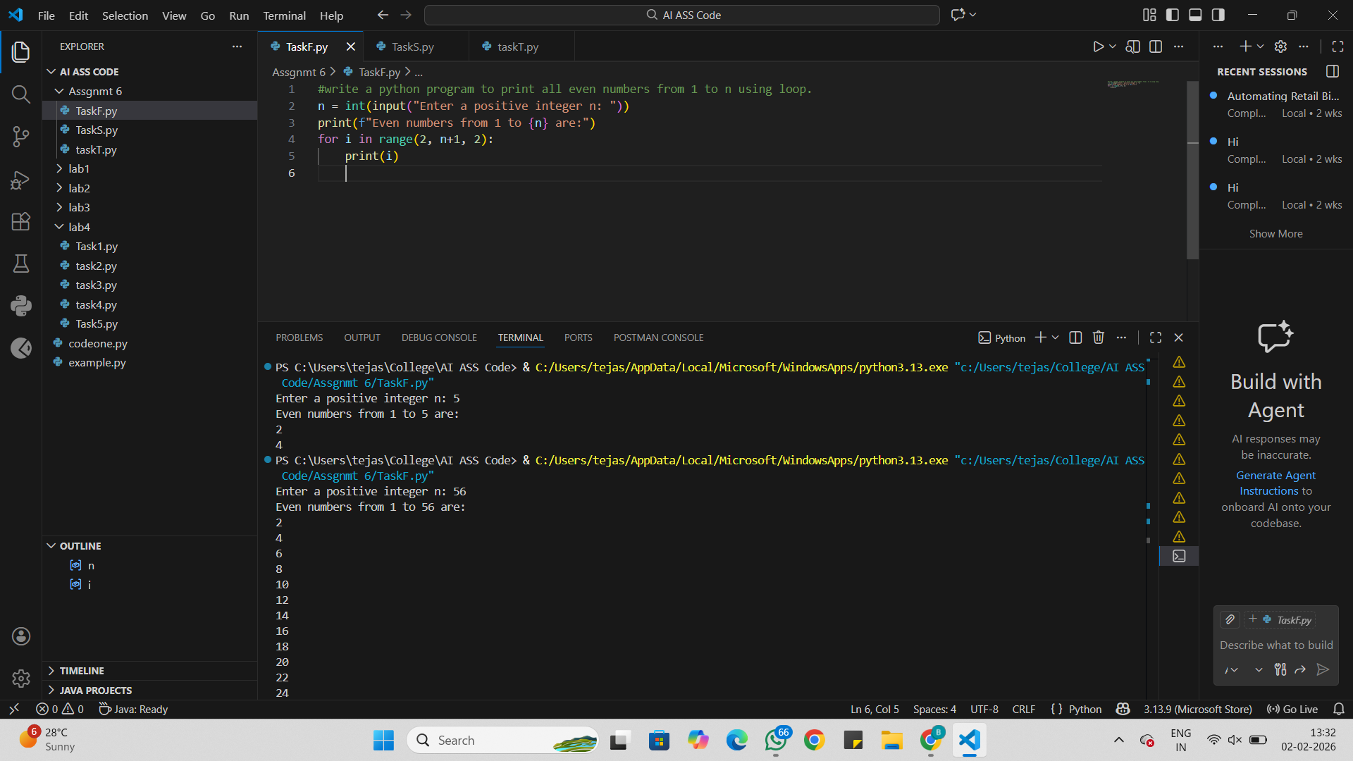
Analysis:
The program asks the user to enter a number n.
The number is stored in the variable n.
The loop starts from 2 because 2 is the first even number.
The loop increases by 2 each time.
Only even numbers are printed up to n.

Task Description #2 (AI-Based Code Completion for Loop with
Conditionals)
Task: Use an AI code completion tool to combine loops and
conditionals.
Prompt:
“Generate Python code to count how many numbers in a list are even
and odd.”
Expected Output:
• AI-generated code using loop and if condition.
• Correct count validation.
• Explanation of logic flow.
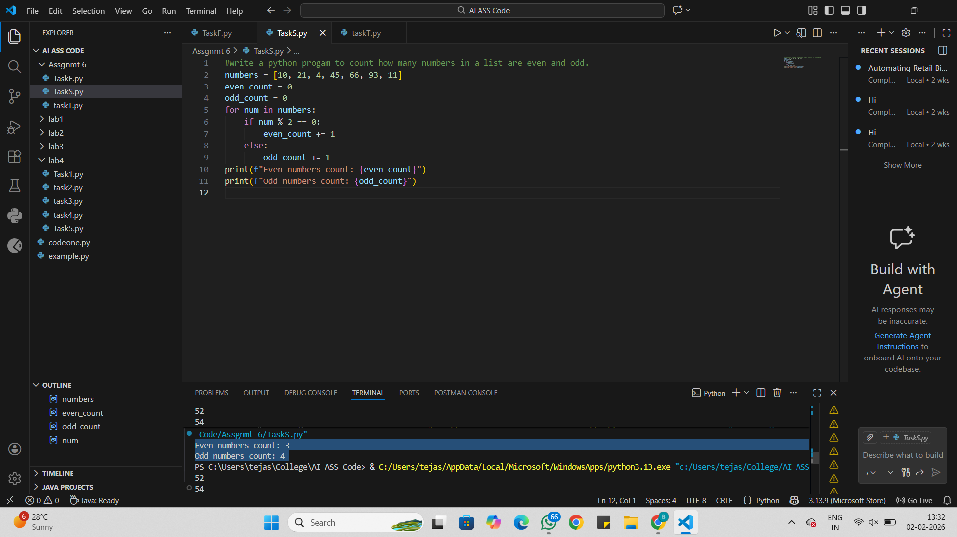
Analysis:
A list of numbers is stored in the variable numbers.
Two variables, even count and odd count, are set to 0.
The program checks each number in the list using a for loop.
If a number is divisible by 2, it is even, so even count is increased.
Otherwise, the number is odd, so odd count is increased.
Finally, the program prints the total count of even and odd numbers.

Task Description #3 (AI-Based Code Completion for Class
Attributes Validation)
Task: Use an AI tool to complete a Python class that validates user
input.
Prompt:
“Generate a Python class User that validates age and email using
conditional statements.”
Expected Output:
• AI-generated class with validation logic.
• Verification of condition handling.
• Test cases for valid and invalid inputs.
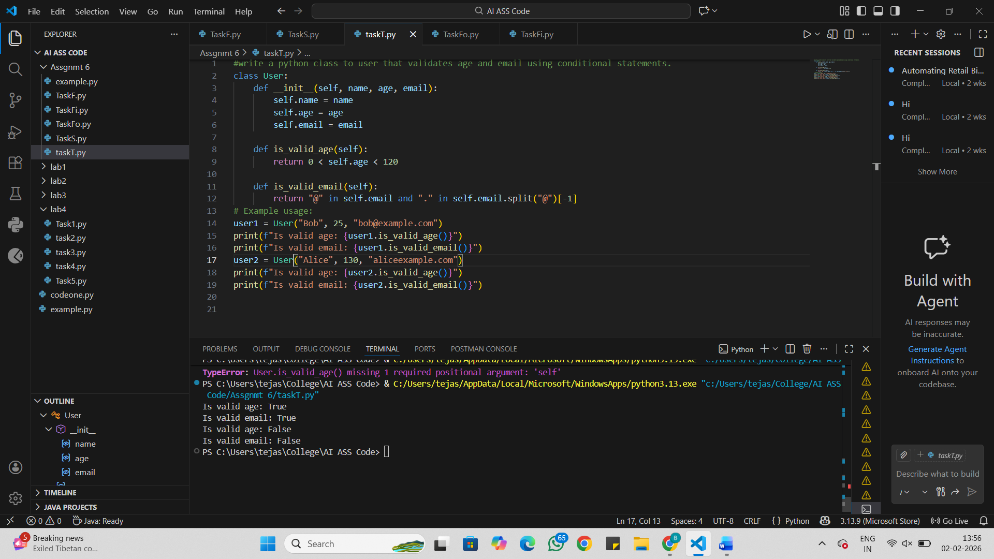
Analysis:
A class named User is created.
The init method stores the name, age, and email of the user.
The method is valid age() checks if the age is between 1 and 119.
The method is valid email() checks if the email:
- contains @
- has a . after @
A user object is created and the validation results are printed.
The same checks are done for another user with invalid details.

Task Description #4 (AI-Based Code Completion for Classes)
Task: Use an AI code completion tool to generate a Python class for
managing student details.
Prompt:
“Generate a Python class Student with attributes (name, roll number,
marks) and methods to calculate total and average marks.”
Expected Output:
• AI-generated class code.
• Verification of correctness and completeness of class
structure.
• Minor manual improvements (if needed) with justification.
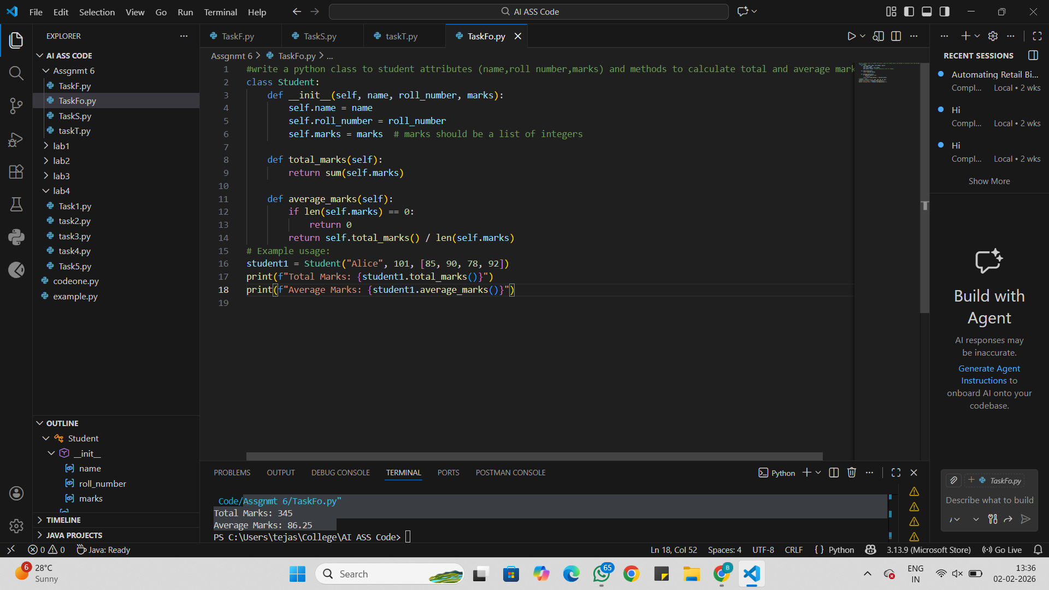
Analysis:
A class named Student is created.
The __init__ method stores the student’s name, roll number, and marks.
The total marks() method adds all the marks and returns the total.
The average marks() method:
- checks if the marks list is empty
- calculates the average by dividing total marks by number of subjects
A student object is created and the total and average marks are printed.

Task Description 5 (AI-Assisted Code Completion Review)
Task: Use an AI tool to generate a complete Python program using
classes, loops, and conditionals together.
Prompt:
“Generate a Python program for a simple bank account system using
class, loops, and conditional statements.”
Expected Output:
• Complete AI-generated program.
• Identification of strengths and limitations of AI suggestions.
• Reflection on how AI assisted coding productivity.
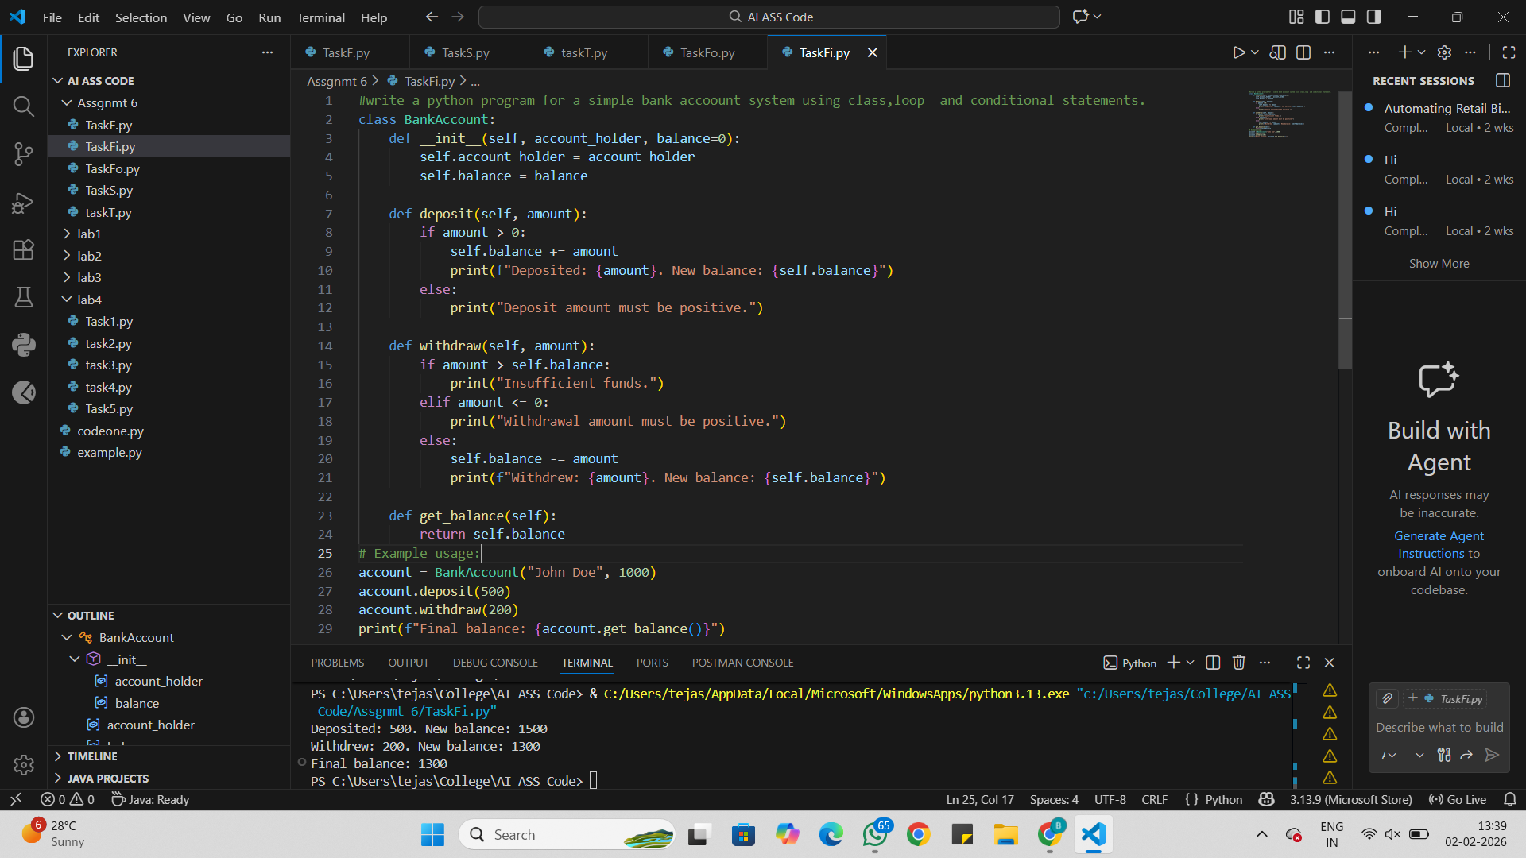
Analysis:
A class named BankAccount is created.
The init method stores the account holder name and balance.
The deposit() method:
- checks if the amount is positive
- adds the amount to the balance
The withdraw() method:
- checks if there is enough balance
- checks if the amount is positive
- subtracts the amount from the balance
The get_balance() method returns the current balance.
The program performs deposit, withdrawal, and prints the final balance.

